**Emotion analysis in social media**

**136041 AR (2021W)**

**Mag. Mag. Dr. Andreas Baumann**

**Report**

**Emotional Attributes of diverging political spheres on Twitter**

# **1. Introduction**

For our project, we decided to take a closer look at political communication on the social network Twitter. With 397 million users Twitter has a share of almost nine percent of the world’s overall social media user base and has become an important platform for politicians, regardless of which party, to share and spread their messages in the form of tweets. This huge amount of produced text can be used to analyze people’s emotions and opinions. For politicians social networks can serve two potential purposes – on the one hand, they can circumvent constraints from other political users and - what might be even more important - it is used to amplify the politician's messages which are usually accompanied by (strong) emotions. Therefore, content produced on Twitter is a substantial origin of information for emotion analysis and opinion mining.[1]

As Hasan et al. noted, techniques to detect the emotions expressed in microblogs and social media posts like tweets have a wide range of applications including measuring the public mood of a certain (political) community. A major challenge for emotion detection is that emotions are very subjective concepts that cannot be separated clearly with variations in expression and perception.[2]

In a very simple analysis approach, a text can be classified as positive, negative, and neutral. A more common approach for sentiment analysis studies is based on Ekman's Model of Basic Emotions[3] including anger, surprise, disgust, enjoyment, fear, and sadness. For our purpose, we decided to apply an emotion lexicon that allows us to detect dominance, valence, arousal, fear, and anger for every tweet which is going to be explained in more detail later in this report.The expressed emotion plays a significant role when it comes to the grade of influence on the public and from the scientific literature emerges that “Emotions are prevalent in the rhetoric of populists”[4]. As Valentim and Widmann[5] could prove, (radical) right parties tend to use more negative emotions than their counterparts do.

Therefore we assume a higher occurrence of emotions such as aggression, dominance - i. e. assertive language - in the tweets of the politicians on the right spectrum than for the politicians on the left. To account for the whole spectrum of the political Twitter-sphere as well as for a possible divergence between Austrian and German parties, the scope of the dataset ranges from (far) right to (far) left politicians. For this reason, the corpus consists of tweets from the parties Bündnis 90/die Grünen (Germany) and Die Grünen (Austria) for representing the left side of the spectrum and AfD (Germany) and FPÖ (Austria) for the right spectrum.

It is presumed that a higher occurrence of assertive language in Tweets of the right spectrum can be observed. Following our preliminary hypothesis, our corpus only consists of German and Austrian politicians, who are still active on a federal level. To extract such subjective information like emotions from natural language texts dictionary-based sentiment analysis will be applied. To gather data that suits our interest perfectly we worked with tweets scraped directly from Twitter via the R library *rtweet*.

# **2. Gathering & Preprocessing the data**

In order to retrieve the required Twitter feeds of the respective politicians, who we defined as being of interest for our further analysis at the outset of our project, we opted for scraping the user timelines in question by connecting to the official Twitter API and making use of the functions provided by the R library *rtweet*. The following code snippet shows in detail the function, which was used in order to access a respective timeline of a respective user:

scrape_tweets <- function(userID, n_tweets, filename){

tweets <- get_timeline(userID, n_tweets, include_rts=FALSE, exclude_replies=TRUE)

tweets_df <- as_data_frame(tweets)

tweets_df <- tweets_df %>%

select(c(status_id, text, screen_name, created_at, favorite_count, retweet_count))

write.csv(tweets_df, paste(filename,"-tweets.csv", sep = ""), row.names = FALSE)

}

for (id in id_list) {

scrape_tweets(id, 3200, id)

}

Figure 1: Function for scraping tweets.

For every user, whose Twitter-ID is saved to a single list, containing all the different IDs of the different politicians, and then fed into the function via a simple for loop, the function scrapes the first 3200 recent tweets (excluding retweets) and pastes them into a single csv data frame. The native function of *rtweet* already allows for getting the favorite and retweet count for every tweet, which we also decided to include for our further quantitative analysis. In order to guarantee an even distribution of the respective tweet counts for a given user - the problem being here that not every user activity exceeded the amount of 3200 tweets - and also to enhance processing speed we cut down the initial amount of tweets per user to the most recent 400 so that we ended up with 4799 tweets in total, evenly distributed across all the different politicians.

Afterwards, a cleaning function was defined, which takes the column with the textual tweet data as an input and then runs some standard cleaning procedures over it:

cleaning_tweets <- function(text){

text <- gsub("http.+", "", text)

text <- gsub(",", "", text)

text <- gsubfn(pattern = "[[:punct:]]", engine = "R",

replacement = function(x) ifelse(x == "#", "#", ""),

text)

text <- gsub("[[:digit:]]", "", text)

text <- gsub(" ", " ", text)

text <- tolower(text)

}

Figure 2: Function for cleaning the tweets.

The function mainly uses regular expressions to filter out unnecessary strings within the tweets such as links, punctuation and digits. Note that we still decided to keep the hashtags, which could for example be used for some insightful visualisations (e. g. wordclouds) and other more specific analysis. Last but not least the textual data was also put entirely into lower case as a standardisation technique. In addition to this initial cleaning procedure we also removed all the stopwords since they would not add any significant meaning to our analysis. For this we mainly relied on the NLP library *quanteda* and its built-in list of german stopwords, which already provided us with satisfyingly clean results.

Another crucial step in the preprocessing phase was to join the *MEmoLon Emotion Dictionary* by Sven Buechel et al.[6] with our dataset to compute the scores dominance, valence, arousal, fear and anger for every tweet. For this we needed to convert the text column of the dataset into a word frequency matrix, which we did via the following function:

tweets_words <- function(text){

words <- strsplit(text, " ")[[1]]

tf <- table(words)

tf <- as.data.frame(tf)

colnames(tf) <- c("word", "frequency")

tf <- subset(tf, is.element(word, stopwords_de) == FALSE)

return(tf)

}

Figure 3: Converting the textual tweet data into a word frequency matrix.

First the respective tweet is split into words by using the spaces as word boundaries and then the count of every word is included as the second dimension of frequency. Afterwards the emotion dictionary is joined with the word frequency matrix and the average emotion scores for a respective tweet are calculated with the given formula, where freq stands for the frequency of a given word and emo means the respective emotion attribute.

$$\sum_{1}^{n}{}(freq * emo)/\sum_{1}^{n}{}freq$$

Figure 4: Formula for computing emotion scores.

join_dict_valence <- function(words, dict){

tf <- tweets_words(text)

combined <- merge(tf, dict, by="word")

score_valence <- sum(combined$frequency * combined$valence) / sum(combined$frequency)

return(score_valence)

}

texts <- paste(tweets_clean_joined$text_clean, tweets_clean_joined$text_clean, sep = " ")

valence_scores <- c()

for(i in 1:nrow(tweets_clean_joined)){

text <- texts[i]

scores <- join_dict_valence(text, dict)

valence_scores <- c(valence_scores, scores)

}

Figure 5: Joining the dictionary and computing emotion score.

The code snippet above shows in detail the joining of the word frequency matrix with the emotion dictionary and its following calculation of the valence score by using the aforementioned formula and putting it into a for loop. As a final result the valence scores for all the tweets are returned as a vector, which can then be easily merged with the already existing dataframe. The procedure of computing the other emotion scores is analogous to the presented valence example. The final dataset contains 4799 rows times 19 columns, which are as follows:

* status_id: a unique ID for the respective tweet
* text: contains the raw, unprocessed tweets
* screen_name: the twitter ID for the respective user
* created_at: the timestamp when the respective tweet was created in the format YYYY-MM-DD HH:MM:SS
* favorite_count: the count of favourites for the respective tweet
* retweet_count: the count of retweets for the respective tweet
* text_clean: contains the cleaned, preprocessed tweets
* date: the date when the respective tweet was created in the format YYYY-MM-DD
* name: the full name of the respective user
* left_right: a boolean column which can either be 0 or 1 and indicates the political affiliation of the respective user
* party: the party affiliation of the respective user
* country: the country of residence of the respective user - can either be Austria or Germany
* valence: the average valence score for the respective tweet
* arousal: the average arousal score for the respective tweet
* dominance: the average dominance score for the respective tweet
* anger: the average anger score for the respective tweet
* fear: the average fear score for the respective tweet

# **3. Results & Discussion**

After joining the tweet corpus and dictionary we created an array of different visualisations of all the potentially viable combinations of emotional properties, affiliation to a party, nationality, as well as the progression of, or rate of change of the discrete variables throughout time for each of them. We used several different types of plots to get a firmer grip on our data: scatter plots for looking into the correlation between two different parameters, violin plots and box plots for the relative distribution of emotional values within each of our selected groups and lastly histograms for the total distribution of a group with regards to an emotional parameter. These, here exemplarily represented through a histogram of the distribution of the fear values, do not offer a decisive indicator for the support of the alternative hypotheses laid out in the political science papers we set out to evaluate in our sampled twitter data of political discourse.

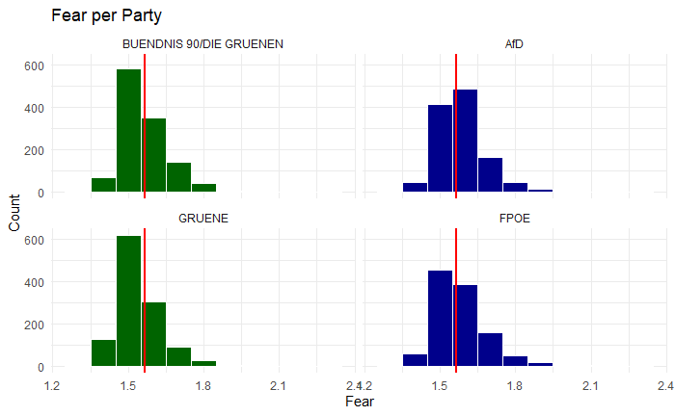

Figure 6: Exemplary value distribution - fear per party

In order to underlie our assessment with numeric dimensions, we calculated an array of descriptive statistics to determine the general properties of our parameters and get a concrete impression of the underlying distribution of the data. For this we calculated the mean and standard deviation of all five emotional categories and in presupposition of a skew within the data included the median values and interquartile ranges for them as well. Those, while carrying some measure of variance when comparing the different emotions with each other, contrary to our alternative hypothesis, did not show a readily apparent deviation among the different parties or countries with respect to the same score, which would exceed the second decimal point.

To test for interactions among the properties of the data, we took a look at a correlation matrix of all the numerical variables among our dataset. Having anticipated a potential non-linear relationship between the retweet count and some of the emotional attributes, we opted for Spearman’s Rho as the measure and in order to ensure that the potential range of data is taken into account appropriately evenly weighted, the R.scale() function was used in order to standardise the data first. Some of the emotional scales seem to be highly correlated with each other; respectively: valence, with dominance, anger and fear and additionally, dominance with anger and fear, as well as anger with fear. Studies indicate that anger and fear are often associated with each other. Furthermore, it is revealed that anger fear, and sadness are correlating with high dominance[7], which supports the result.

As is to be expected, the favourite count and retweet count are also strongly correlated, since the reach of a tweet most likely corresponds to its appeal to users and vice versa.

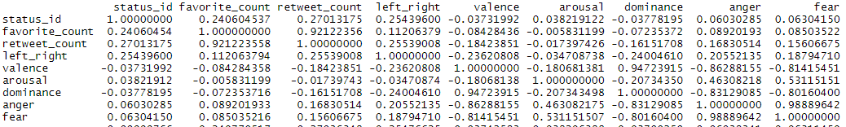

Figure 7: Correlation Matrix of numeric values

In order to get definite proof of our assessment we assembled a selection of Mann-Whitney-U-Tests and compared the distribution of emotional values among each possible grouping of political affiliations and nationality for the assumption of variance between them. While the assumption of a difference in terms of underlying value distribution could not be accepted for any one set of parameters with a 95 % level of significance, it could not be discarded with a 99 % level of significance for the following groupings:

* Level of anger laden expressions between German right-wing and left-wing parties
* Level of fear laden expressions between German right-wing and left-wing parties
* Level of anger laden expressions between Austrian right-wing and left-wing parties
* Level of fear ladden expressions between Austrian right-wing and left-wing parties
* And following this only naturally, the level of fear and anger laden expressions within right-wing and left-wing politicians irrespective of nationality.

We looked into the wordcloud functions of the quanteda package in order to get further insight and see if this weak trend could be observed within the selection of most common words through the help of manual interpretation.

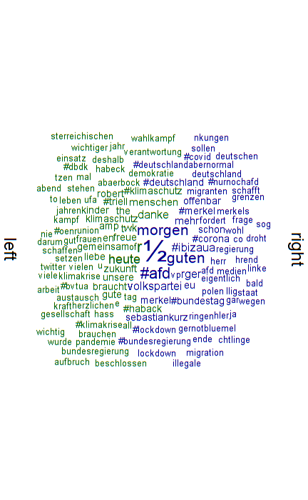

Figure 8: Comparative word cloud of the most frequent terms within left-wing and right-wing parties

While it can be observed how both sides of the spectrum use the terms related to their major topics with higher frequency, there can not be attributed a clear or distinct emotional weight to the terms in use, since they are at their core issue-related and less emotionally explicit.

Lastly, in order to evaluate the relationship between the expression of emotion and the subsequent success of a tweet, quantifiable through the retweet or the favorite count, we looked further into a polynomial regression model, since the distribution of the data points within the first sighting hinted at a potential for such. The retweet count reaches a certain maximum at roughly the median of the dataset and then declines again.

For the implementation of the polynomial regression model we first split the dataset into a training and a testing set. Then we created the model with the predictor’s valence, arousal, dominance, fear and anger to a polynomial degree of 2, and defined our target variable as the retweet count column. Unfortunately, the base model reports very low accuracy scores with a Root Mean Square Error (RMSE) of 127.0689 and a R² of only 0.03734757. In order to increase the flexibility of the fitted regression line, we still implemented a Generalized Additive Model (GAM) which is provided via the library *mgcv* and automatically splits the regression curve into a number of different splines, whereas each spline gets attributed its own local degree of flexibility and then gets joined via knots to describe one single - albeit more flexible - regression curve again. Nevertheless, this additional approach only improved the final model slightly with a new RMSE of 126.9036 and an R² of 0.04069951, which is still way too low to be of any considerable use. Therefore it must be concluded that the quadratic relationship between the number of retweets and the emotion parameters is not significant enough to build a sound statistical model with predictive qualities.

set.seed(19)

sample <- sample.int(n = nrow(tweets_scatter), size = floor(.70*nrow(tweets_scatter)), replace = FALSE)

train <- tweets_scatter[sample, ]

test <- tweets_scatter[-sample, ]

model <- lm(retweet_count ~ poly(valence, 2, raw = TRUE) + poly(arousal, 2, raw = TRUE) + poly(dominance, 2, raw = TRUE) + poly(fear, 2, raw = TRUE) + poly(anger, 2, raw = TRUE), data = train)

predictions <- model %>% predict(test)

modelPerfomance = data.frame(

RMSE = RMSE(predictions, test$retweet_count),

R2 = R2(predictions, test$retweet_count)

)

print(model)

print(modelPerfomance)

# using splines for improving fitting accuracy

model_gam <- gam(retweet_count ~ s(valence) + s(arousal) + s(dominance) + s(fear) + s(anger), data = train)

predictions_gam <- model_gam %>% predict(test)

modelPerfomance_gam = data.frame(

RMSE = RMSE(predictions_gam, test$retweet_count),

R2 = R2(predictions_gam, test$retweet_count)

)

print(modelPerfomance_gam)

Figure 9: Polynomial Regression model

# **4. Conclusion**

As pointed out above, the analysis could only confirm the null hypothesis with a 95% level of significance and thus the alternative hypothesis remains to be falsified. On the other hand, further statistical enquiries showed that at the level of 99% significance there at least appears to be a slight deviation from the norm, which could for the time being not fully discard the alternative hypothesis and might also provide a basis for a more thorough and detailed analysis in the future.

For potential future investigations, it would be recommendable to use a variation of different lexica for emotionally classifying the tweets, in order to determine whether a different distribution of the emotional predictive scores could skew the subsequent results in a significant way. Last but not least through stemming or lemmatization of the tweets additional accuracy in the attribution of word occurrences with their related dictionary entries could be achieved, thus potentially representing the perceived value of how emotionally charged speech is more accurately. Subsequent investigations could also look into the discovered correlation between aggression, anger and fear and analyse their interplay in more detail.

# 

# **References**

Bose R., Dey R.K., Roy S., Sarddar D. (2019): Analyzing Political Sentiment Using Twitter Data. In: Satapathy S., Joshi A. (eds) Information and Communication Technology for Intelligent Systems. Smart Innovation, Systems and Technologies, vol 107. Springer, Singapore. <https://doi.org/10.1007/978-981-13-1747-7_41>

Buechel, Sven et al. (2020): MEmoLon. The Multilingual Emotion Lexicon. Learning and Evaluating Emotion Lexicons for 91 Languages. In: <https://github.com/JULIELab/MEmoLon> [22.1.22].

Charlton N, Singleton C, Greetham DV. (2016): In the mood: the dynamics of collective sentiments on Twitter. R. Soc. Open. Sci. 3, 160-162.

Ekman, P. (1992). An Argument for Basic Emotions. Cognition and Emotion. 6, 169–200 .

Grimmer, J., & Stewart, B. (2013): Text as Data: The Promise and Pitfalls of Automatic Content Analysis Methods for Political Texts. Political Analysis, 21(3), 267-297. doi:10.1093/pan/mps028

Hasan, M., Rundensteiner, E. & Agu, E. (2019): Automatic emotion detection in text streams by analyzing Twitter data. Int J Data Sci Anal 7, 35–51. <https://doi.org/10.1007/s41060-018-0096-z>

Mayor, Eric & Bietti, Lucas M. (2021): Twitter, time and emotions. R. Soc. Open. Sci. 8,

Selmela, Mikko & von Schere, Christian (2018): Emotional Dynamics of Right- and Left-wing Political Populism. Sage Journal, Volume: 42, Issue: 4, pages: 434-454.

Javela, J. J., Mercadillo, R. E., & Martín Ramírez, J. (2008). Anger and associated experiences of sadness, fear, valence, arousal, and dominance evoked by visual scenes. Psychological reports, 103(3), 663–681. https://doi.org/10.2466/pr0.103.3.663-681

Valentim, Vicente & Widmann, Tobias. (2021). Does Radical-Right Success Make the Political Debate More Negative? Evidence from Emotional Rhetoric in German State Parliaments. Political Behavior.

# **Appendix**

For the full source code visit: <https://github.com/DavidSiegl/Emotion-Analysis-Project>

For downloading the dataset see also: <https://phaidra.univie.ac.at/detail/o:1415722>

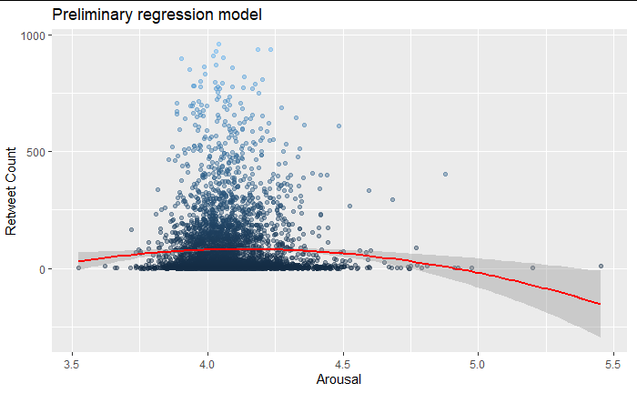

Appendix 1: Scatterplot for the linear correlation between retweet count and arousal

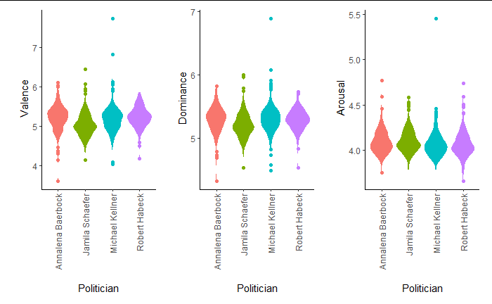

Appendix 2: Violinplots for valence, dominance and arousal for Bündnis 90/die Grünen (Germany)

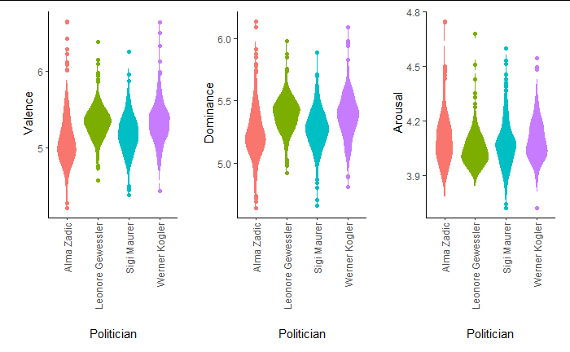

Appendix 3: Violinplots for valence, dominance and arousal for Die Grünen (Austria).

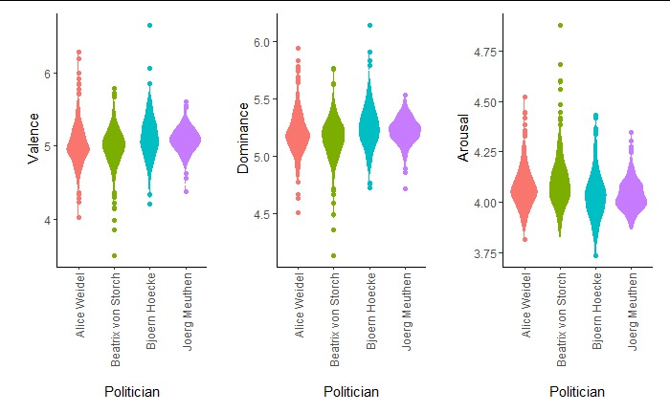

Appendix 4: Violinplots for valence, dominance and arousal for AfD (Germany)

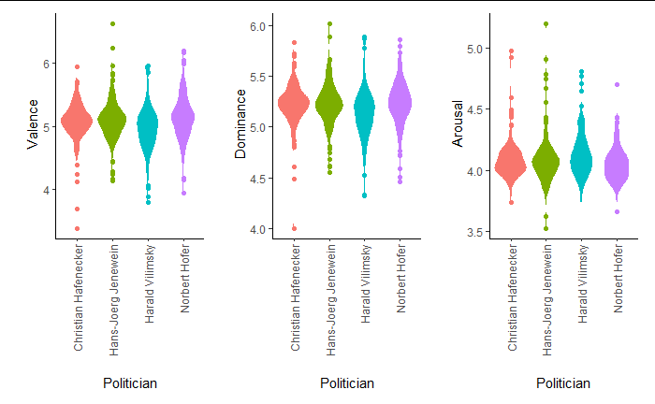

Appendix 5: Violinplots for valence, dominance and arousal for FPÖ (Austria)

1. Bose R., Dey R.K., Roy S., Sarddar D. (2019) Analyzing Political Sentiment Using Twitter Data. In: Satapathy S., Joshi A. (eds) Information and Communication Technology for Intelligent Systems. Smart Innovation, Systems and Technologies, vol 107. Springer, Singapore. <https://doi.org/10.1007/978-981-13-1747-7_41>
2. Cf. Hasan, M., Rundensteiner, E. & Agu, E. (2019). Automatic emotion detection in text streams by analyzing Twitter data. Int J Data Sci Anal 7, 35–51. <https://doi.org/10.1007/s41060-018-0096-z>
3. Ekman, P. (1999). Basic emotions. In *Handbook of cognition and emotion* (Vol. 98, pp. 45–60).

  
4. Selmela, Mikko & von Schere (2018). Christian Emotional Dynamics of Right- and Left-wing Political Populism. Sage Journal, Volume: 42, Issue: 4, p. 435.
5. Valentim, Vicente & Widmann, Tobias. (2021). Does Radical-Right Success Make the Political Debate More Negative? Evidence from Emotional Rhetoric in German State Parliaments. Political Behavior.
6. For further details and download instructions visit: <https://github.com/JULIELab/MEmoLon> [22.1.22].
7. Javela, J. J., Mercadillo, R. E., & Martín Ramírez, J. (2008). Anger and associated experiences of sadness, fear, valence, arousal, and dominance evoked by visual scenes. *Psychological reports*, *103*(3), 663–681. https://doi.org/10.2466/pr0.103.3.663-681